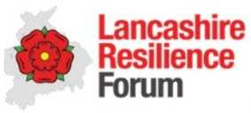

LRF COVID 19

SOUTH RIBBLE Local Prevention Zone

DRAFT Framework for local plan

Dated 23nd July 2020

- Assessment

LOCATION | South Ribble Borough Council
DYNAMIC RISK ASSESMENT | SEE ANNEX B
DATE FRAMEWORK LAST REVIEWED | 23.7.20

- Situation

Using indices of positive cases in pillar one and pillar two, positivity rates and exceedance reports it is apparent that the incidence of coronavirus is reducing across Lancashire in general, and the number of cases of coronavirus per 100,000 people is reducing in South Ribble with cases having reduced to 2.7 per 100,000 (18.7.20). Over the last 7 days there has been an increase of testing to 103.1 per 1000,000 population and the percentage of people testing positive is 0.4% which is decreasing. There have been no recorded community outbreaks and only 3 confirmed cases within the last 7 days

Currently South Ribble is RAG rated Green. A RED rating is given if the threshold is exceeded for two or more of the 14 most recent days regardless of the magnitude of the exceedances, OR if the observed cases per 100 tests is greater than the forecast mean value for 12 of the 14 most recent days. An AMBER rating is given if the threshold is exceeded for only one of the 14 most recent days, OR if the observed cases per 100 tests is greater than the forecast mean value for 10 or more of the 14 most recent days. Otherwise a GREEN rating is given.

No access to postcode level data at South Ribble level as yet

- Purpose of this plan

The aim of this plan is to further reduce the already low rates in South Ribble and ensure continued compliance by both businesses and the members of the public with Covid-safe regulations in order to maintain low rates of infection.

Key messages around the need for the community to continue to understand we all have a part to play to help tackle the virus. Messages to our community will continue:
- stay at home as much as possible
- work from home if you can
- limit contact with other people
- keep your distance from people not in your household (2 metres apart where possible)
- wash your hands regularly
- Do not leave home if you or anyone in your household has symptoms.

Proactive working with our Business community is key to keeping the rates low in South Ribble. An education campaign has been undertaken with our local businesses and to ensure businesses will not become complacent regular visits will be made to all high-risk businesses on the district. More high-risk businesses will be opening over the next week including leisure operations, gyms and facial beauty and these businesses will be targeted. Messaging to businesses have been quite confusing especially for small businesses and we will help them understand their duty to ensure they are maintaining good standards of compliance in their premises.

South Ribble has developed a community hub which has supported our vulnerable residents to stay at home and limit contact with other people. The hub will continue to support our residents during this next phase of the pandemic.

- What impacts do we want to have?

- To reduce sources and rates of transmission
- To promote symptomatic testing
- To educate and reassure the local population with general messaging
- To educate targeted groups
- To improve case finding with daily data
- To bring about more timely contact tracing
- To increase asymptomatic testing
- To restrict mass gatherings

- Where is this happening?

Need postcode level data

Currently rates in South Ribble are low, but work is ongoing to target the high-risk community and business settings. These include education campaigns in houses of multiple occupation, shelters, homeless accommodation and in businesses in the food, beauty and leisure sector.

- Community Support

Community support and protecting community cohesion is crucial for the success of this plan, as it requires behaviour change and awareness of how cultural norms affect infection rates. We have an existing community engagement network to enable us to communicate with key community contacts, elected members, and stakeholders in the relevant wards, as well as pan-borough representative groups, to inform them of the situation, and provide reassurance. We are engaging with our community via social media and specifically raising awareness in high risk settings.

We will discuss the messages with our community to ensure any proposed measures are supported by the community. We will link in with our BAME groups to ensure messages are sent on a risk-based approach.

- Dynamic Risk Assessment

We are adopting a dynamic risk assessment framework, based on our intelligence and evidence base to inform the local plan. We intend to use this as a guide to review the situation across our localities on a regular basis. We will adapt this as national policy evolves.

We are reviewing the situation and actions daily on the SCG pacesetter based on the test positivity 1.7 %, positive per hundred thousand, effectiveness of NHS test and trace service, and all the local intelligence we collect. Our ongoing monitoring and public health professional assessment may trigger more interventions as appropriate and will also be used to deescalate measures. Other indicators will be used such as:
- Trend on small areas (MSOAs, LSOAs) worsening
- NHS 111 triage
- Hospital admissions
- Outbreak surveillance
- Soft Intelligence e.g. changes to testing/local behavioural intelligence

- Plan and Course of Actions

The plan and course of action in South Ribble is to ensure the low rates of community transmission stay low by focusing on community engagement, to ensure national guidance are followed; promoting uptake of testing; enhanced inspection support; monitoring.

- Lancashire Resilience Forum (LRF) Warning and Informing Cell will disseminate key messages across the borough and county, continuing to provide the national information on preventative measures that the public can take to reduce the transmission of the virus, signposting testing opportunities and advising on the action needed after a positive test result in order to prevent further transmission. These key messages will be disseminated by South Ribble Borough Council via social media and main stream media and will also be targeted at our vulnerable to the virus in our community.

- The South Ribble Borough Council’s Environmental Health and Communities team will conduct inspections of priority settings, to provide engagement and education on infection prevention, ‘Covid secure’ best practice and, where necessary, enforcement action, to reduce the opportunities for transmission of the virus. Additional recruitment will take place next week to further this this targeted approach.

- Recognising the lessons learned from other areas, and that proportionate interventions should be led by intelligence or evidence, the Director of Public Health for Lancashire, on behalf of the LRF, will make representations to the Department of Health and Social Care to obtain day-by-day data.

- Action Summary

 | Action | Owner | Notes including key dates
1 | Measures to reduce community transmission:  - Increase visits from Environmental Health to shops and businesses  - Visits made following non-compliant reports. Intelligence lead targeting for smaller businesses.  - Advice and guidance issued sector related.  - Information sent to vulnerable residents  - Increase awareness of support available for people who are isolating. Letters sent regarding the Hub.  - Posters in parks and play areas – social distancing.  - Audits will be undertaken of high risk premises such gyms and beauty salons.  - Recruitment of additional member of staff to undertake prevent work and outbreak control. | Environmental Health Team. | Work has been undertaken on education now will move on to audits of premises to assess compliance 27.7.20
2 | Key messages to shops and supermarkets in the borough re face coverings including forewarning about proactive spot checks by council officers | Laura Barton Williams | Social media from 24.7.20
3 | Produce materials for businesses including posters and advice guides and deliver these to high risk businesses. | Environmental Health Team. | Posters available on web site. Visits will be made by EH from 27.07.20
4 | Education of community groups including BAME groups to drive behavioural change. | South Ribble Partnership | Partnership meeting to be arranged week commencing 27.07.20
5 | Improve test and trace timelines and discuss with PHE integration of level 2 and 3 contact tracing | Sakthi Karunanithi | Week commencing 27.07.20
6 | Educate the taxi trade and general information regarding sharing vehicles for work. | Licensing | Information designed and proactive visits will be made to operators. Week commencing 27.07.02
7 | Enforcement will be undertaken in the form of improvement notices, prohibition notices or review of Licenced premises if businesses fail to improve. | Environmental Health | Week commencing 27.07.20
8 | Digital support  - Web content  - Customer Services.  Media queries | Laura Barton Williams | Web site hub regularly updated for both resident and business support.
9 | Communication Plan to be developed.  Compliance with hand-washing, social distancing etc.  - Recommendations re use of face coverings in enclosed spaces  - Don’t be a contact i.e. minimising household/social gatherings – | Laura Barton Williams | See below.
10 | Communicate with PHE on need for regular data including post code data with local SPOC | Jennifer Mullin | Data now received on a weekly basis.
11 | Legal powers available for enforcement activities – clarity on roles and responsibility.  The Council’s current Environmental Health enforcement policy to be used to ensure plan for escalation of enforcement is compliant with powers available. | Jennifer Mullin | Document on powers prepared week commencing 27.07.20
12 | Gap identified in local testing and capacity needs to be increased in South Ribble.  Localised training needed for SRBC staff to run testing centre. | LCC
13 | Location of MTU will be identified dependent on risk analysis. Locations based on population density and deprivation. | LCC and SRBC | Risk analysis will be undertaken week commencing 27.07.20.
14 | In the event of a localised outbreak of Covid 19 within Lancashire, Lancashire County Council (LCC) will support Adult Social Care Providers within care homes, supported living, domiciliary care and any other care settings.  In response to a localised outbreak, the county council will support activities to reduce the rate of infection, minimise sources of transmission and contain of specific outbreaks with the following actions; | LCC
15 | Mobilise additional capacity to address outbreak risks and management.  Establish a core team of officers who will mobilise if risk rating of area increases. Capacity increased with Health Protection officer.  Task Force Membership  Gary Hall Interim CEO,  Director of Public Health  Jennifer Mullin District SPOC  LRF Comms Lead  Laura Barton-Williams SRBC Comms Lead.  Community Action Lead Rebecca Heap  RCG Representative.  Out of hour arrangements have been established through Lancashire and mutual aid has been discussed and can be called upon.  The use of the Council’s one front door model will expand our use of community Volunteers to help triage key tasks for the Community Hub.  Ensure coordinated approach across key comms workforce including council, VCFS, NHS, Police etc. Ensure identified SPOC for each group. | Jennifer Mullin | Work commenced and to be completed week commencing 27. 07.20

9. Summary

Whilst the cases in South Ribble are low the Council has been undertaking substantial proactive work in the area. Advice and guidance have been issued to all high-risk businesses and audits will be undertaken of these businesses in the coming weeks. Proactive communications have been undertaken and we will ensure the community is fully aware of both the data and the possible activity and that this is approaching the situation very early to prevent the situation worsening. Engaging with local community including BAME groups and leveraging community leadership is at the heart of the response and actions must be proportionate to the risk.

Lancashire County Council and South Ribble Borough Council remain the key owners of this plan and will have final sign of for actions and messaging with the LRF providing support. This plan will be reviewed regularly as new data arises and subsequent changes or further interventions will be approved by the SCG Leaders and a weekly update provided to the SCG.

Communications Plan

Covid-19 local outbreak
1. Background
This is designed to reach out to local people and businesses, following a slight increase in the number of people who have tested positive for Covid-19 in the South Ribble area.
2. Key Teams
- Communications
- Communities
- Environmental Health
- Investment and Skills
- Partnerships
- Lancashire County Council
- Key agency partners i.e. NHS
- Members
- Customer services
- Leadership team

4. Key dates

N/A | None currently identified – to be added in the event of local outbreak

5. Communications Objectives
- To reach key audiences in specific areas of the borough with advice around controlling the spread of the virus
- To reduce the spread of coronavirus, protecting local people and businesses and allow businesses to safely remain open
6. Key messages

Generalised
- There is evidence that cases are rising in parts of the borough.
- Everyone needs to play their part to control the spread of the virus. If we don’t all stick to the rules, we could go into a local lockdown, like in Leicester.
- We can all protect our family, friends and work colleagues by helping to reduce the spread.
- Get tested if you have symptoms - by getting a test, you can find out if you have Covid and protect people who are important to you.
- Test and Trace helps us to identify where possible cases could be and reduce the spread.
Reducing the spread

- Stay at home if you or anyone in your household has any symptoms
- Wash your hands regularly using soap and water and carry hand sanitiser when you go out
- Keep 2m distance from people not in your household
- Avoid handshakes and embracing when meeting others
- Wear face coverings as per national guidance
- Avoid or limit large extended family gatherings inside.
Businesses

- Make sure your business is covid-secure. See details on our website for advice and support.

7. Key resources
- National coronavirus outbreak figures
- Gov. guidance and guidance given from Cabinet office
- NHS and PHE resources
8. Audiences
- Residents;
- Members;
- Parish Councils;
- Local businesses;
- Staff;
- Customer services – ensuring all public facing messaging is shared with them;
- Local & Regional media
- Lancashire County Council
9. Communications tools
- Traditional press
- Social media
- Website
- Posters in public spaces
- Paid for print and digital advertising
- Photography and video
- Design
- Printed literature

10. Budget
TBC

11. Action plan
Action plan is indicative. Actions will be finalised once any local outbreak is confirmed.

Date | Action | Objective | Channel | Responsibility
 | Prep
TBC (all) | Create localised Let’s do it for… imagery to be used on social media | 1,2 (all) | Social Media | Communications
 | Prepare web pages |  | Website | Communications
 | Prepare any other printed literature |  | Print | Communications
 | Prepare Member briefings |  | Briefing/ Councillor Connect | Communications and Public Protection teams
 | Prepare any internal communications messages |  | Briefing/Intranet | Communications
 | Prepare guidance and FAQs for customer facing teams |  | Briefing | Communications
 | Create toolkits for key partners |  | Cross agency briefings | Partnership, Community and Communications teams
 | Announcing local outbreak
 | Press release with input from LCC Public Health, Leader and Deputy Leader |  | Press release | Communications and LCC comms
 | Social media – imagery and video |  | Social Media | Communications
 | Website – updated guidance and alert messaging |  | Website | Communications
 | Working with LCC for interviews with Dir of Public health |  | Media | Communications and LCC comms
 | E-Newsletter to residents |  | E-newsletter | Communications
 | Reducing the spread
 | Regular social media updates |  | Social media | Communications
 | Paid for localised social media |  | Social Media (paid) | Communications
 | Posters distributed in public spaces |  | Print | Communities
 | Face masks to be made available in centres |  | Within community | Communities
 | Encouraging testing
 | Regular social media of sharing test and trace information |  | Social Media | Communications
 | Up to date web page information |  | Website | Communications
 | Supporting businesses
 | E-newsletter |  | E-News | Communications
 | Posters available for download |  | Website | Communications
 | Updated information on website |  | Website | Communications
 | Direct offers of support |  | Direct contact | Investment and skills and environmental health

12. Additional Documents
- Weekly social media plans
- Briefing document.

ANNEX A
Powers and Policy

SUMMARY OF POWERS

Corona Virus Act 2020 | S52 Sch 22
Public Health (Control of Disease) Act 1984 | - Health Protection (Coronavirus, Restrictions) (England) Regs 2020 – and subsequent amendment regulations currently No's 1,2 &3  - The Health Protection (Part 2A Orders) Regs 2010  - Health Protection (Local Authority Powers) Regs 2010
Health and Safety at Work Act | - Management of Health and Safety at Work Regulations 1999
ASB Crime & Policing Act 2014 | - S1 Injunctions  - S22 Criminal Behaviour Orders  - S43 Community Protection Orders  - S59 Public Space Protection Orders  - S76 Closure Powers

ANNEX B
Escalation Framework

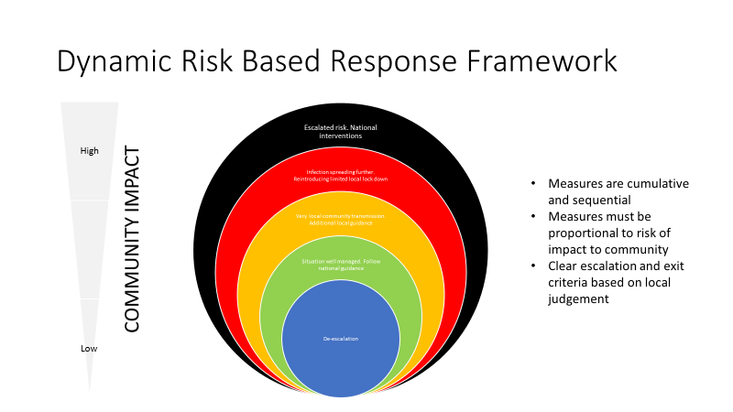

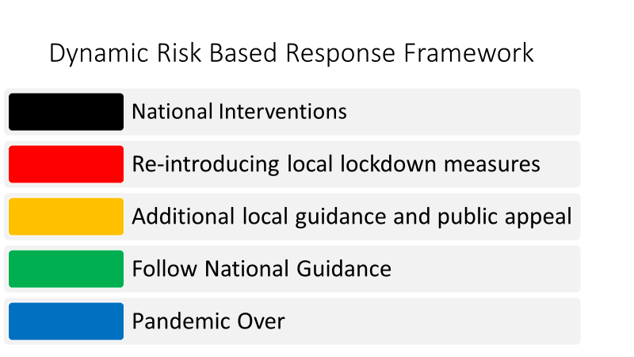

ANNEX C
Example Range of Interventions

This is not an exhaustive list but to demonstrate an escalation of measures from messaging to restrictions.

Messaging and reinforcing national guidance

- A media campaign to reinforce national guidance around handwashing, washing surfaces and social distancing to take place in the location and surrounding locations
- Encouraging communities to seek testing if they are symptomatic
- A targeted campaign within the specific location to enforce strict guidance including ceasing family gatherings, mixing groups outside direct household
- Targeted message campaigns for businesses or settings

Increased Testing and Inspections

- Deploying initial or additional MTU for symptomatic testing
- Opening MTUs for asymptomatic testing
- Organise language facilities at MTU sites
- Organise community swabbing teams to target specific settings
- Increase COVID secure inspections for businesses
- Increase licencing inspections for food and drink establishments

Restrictions

- Mandate facecovering in public
- Enforce social distancing in shops
- Restrict food and drink services indoors
- Closing transport hubs
- Stopping all gatherings
- Close education settings

